Friday, February 3, 2017
12:30 Registration
1:00 Pledge—AG Steve Radich
Introductions & Logistics—District Trainer—Bill Cawley
Welcome—IPDG/VG Rich Storey
Welcome—DGE Ronnie Chantker

Introduction of Rotary Theme 2017-2018
AG’s Response and Insight

1:45 Open Discussion with DGE Ronnie Chantker
      - Presidential & Governor’s Citations and District & Club Recognitions
      - Your Role and Responsibilities as Assistant Governor
      - Area Teams

2:45 Break

3:00 Using Rotary’s strategic planning tool to solve problems in clubs—Bill Cawley

4:00 Rotary Quiz Game

5:00 Wrap-up and Summary Comments

6:00 Social Hour—DGE Suite
7:00 Networking Dinner
Invocation—AG Earl Baughman
Saturday, February 4, 2017

7:00-8:45 Hotel Breakfast

9:00 Rotary Technology

9:45 Open Discussion: Your Role As Assistant Governor at C-PETS—DGE Ronnie Chantker, DRFC/PDG Juanita Cawley & Membership Chair/DGN Glenn Yarborough

10:45 Break

11:00 Conclusion and Summary Remarks

12:00 Adjourn

- March 2-4, 2017: C-PETS
- April 8, 2017: DTTS
- May 6, 2017: DTA
- May 18-21, 2017: District Conference
- June 10-14, 2017: RI Convention
- June 17, 2017: District Awards/Installation Banquet
- July 1, 2017: New Rotary Year Begins

Rotary International District 7610
President-Elect Governor-Elect
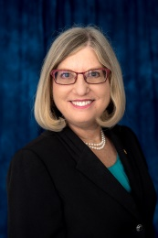
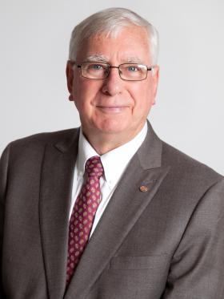

Ian Riseley Ronnie Chantker

President 2017-2018 Governor 2017-2018

Rotary Club of Sandringham Rotary Club of Tysons Victoria, Australia Corner, Virginia, USA

Rotary District 7610 Program
Assistant Governors’ Seminar
February 3—4, 2017
Hyatt Place Hotel
Fredericksburg, Virginia

